Lab Test 2

By: Chahat Chawla (ccha504, 8492142) Github link: <https://github.com/chahatchawla/labtest2ccha504>

Unity project: labtest -> Assets -> labTest2.unity scene ☺

1. 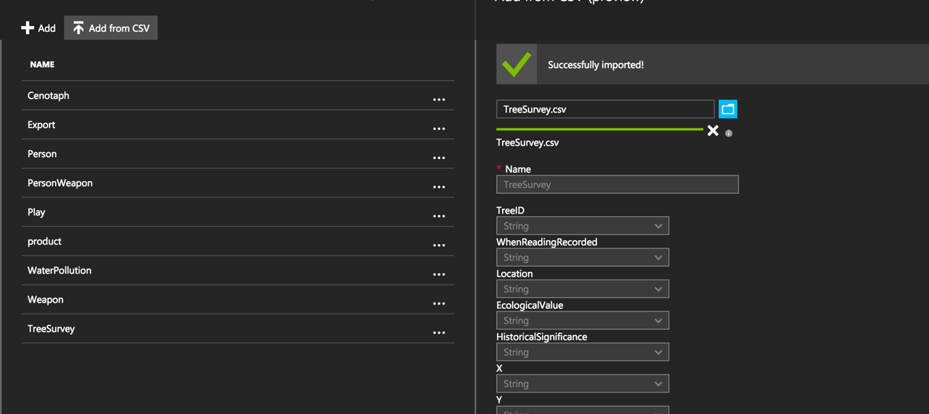Load TreeSurvey.xlsx to Azure
2. 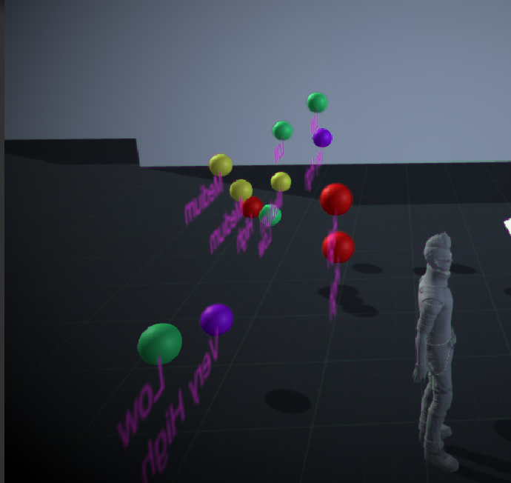Plot into 3D space using any object type – Choose any 3 dimensions

As you can see in these image, 12 spheres are plotted into the 3D Space using the **x y z coordinates** from the TreeSurvey data.

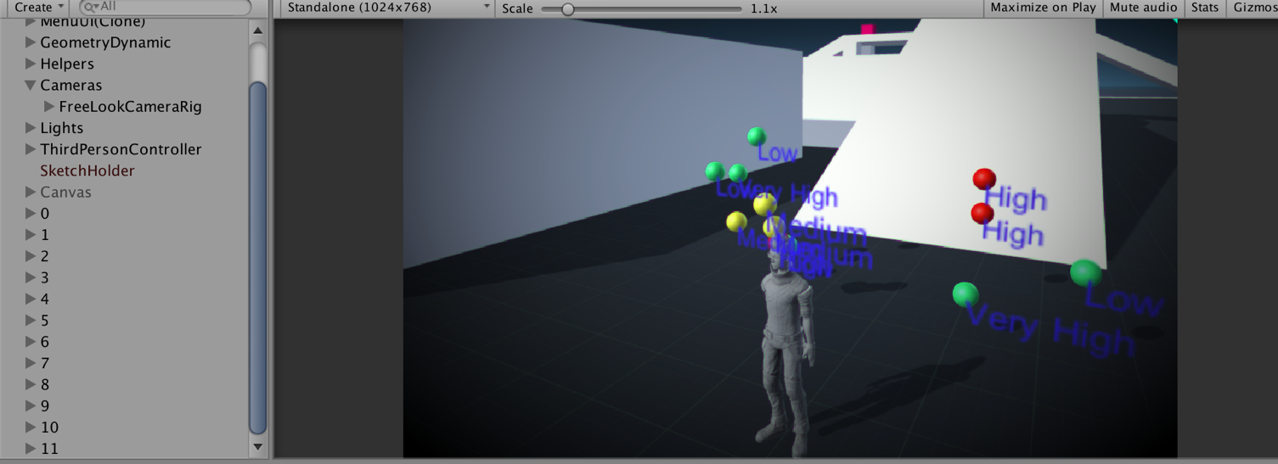

To do this:

1. x, y, z data from table is converted into floats
2. using the coordinate, the SphereWithText prefab is instantiated in the 3D space

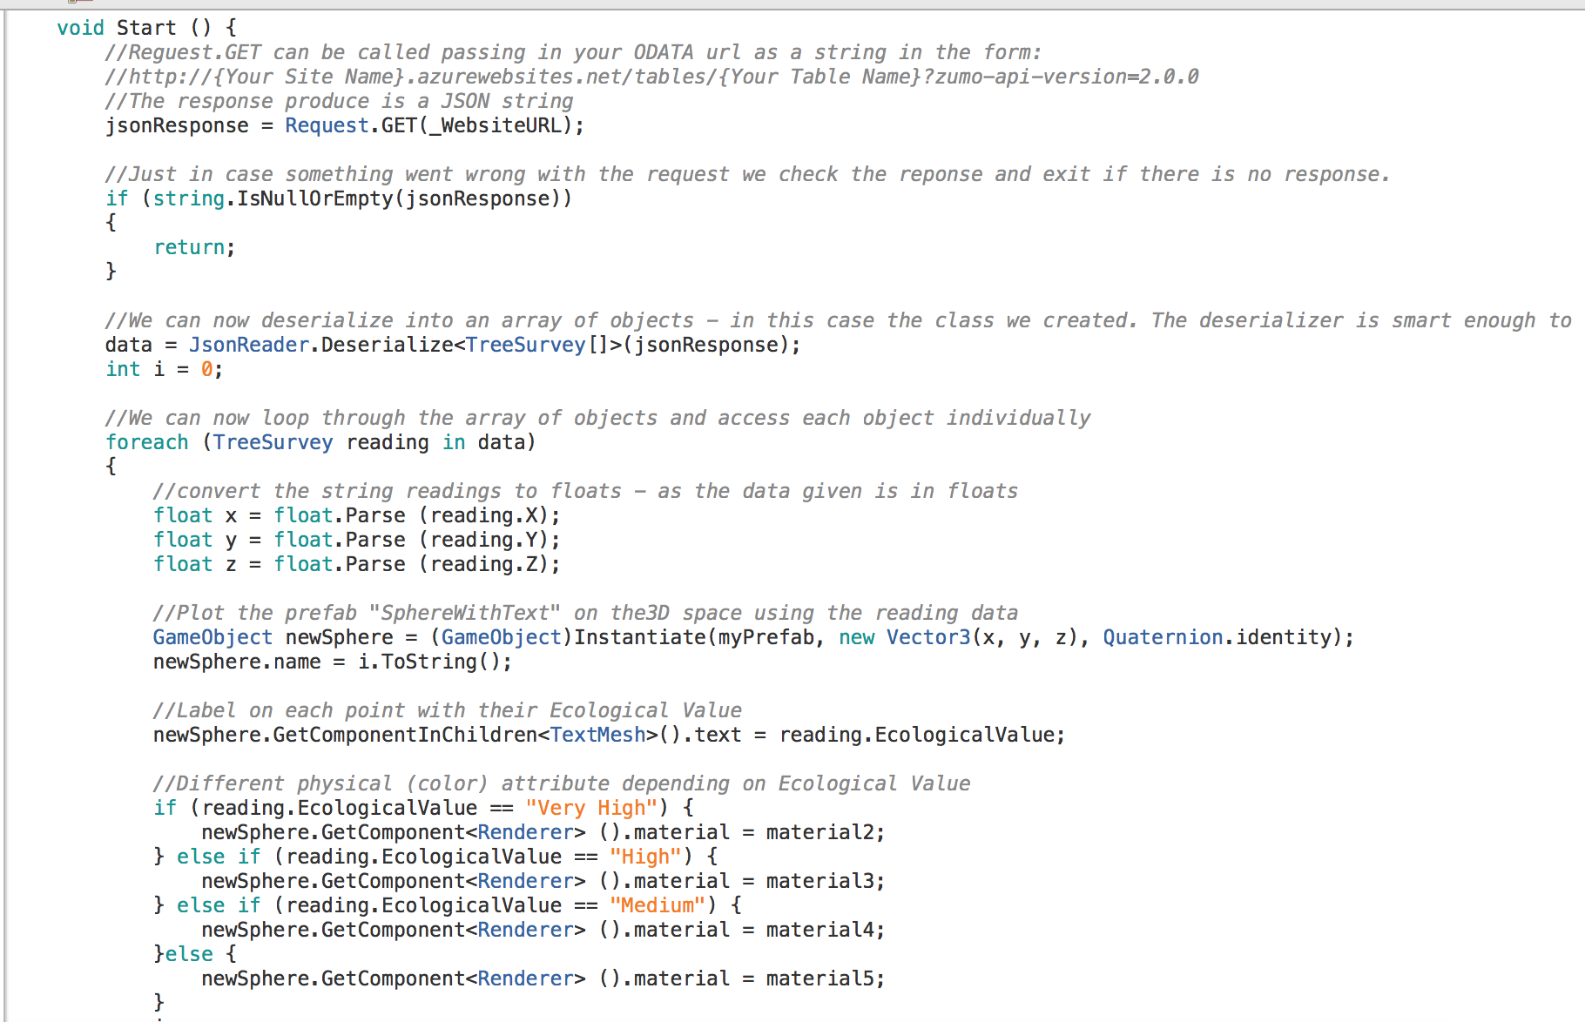

1. Put label on each point

The label chosen is the **Ecological Value** of the reading as it is an important piece of information.

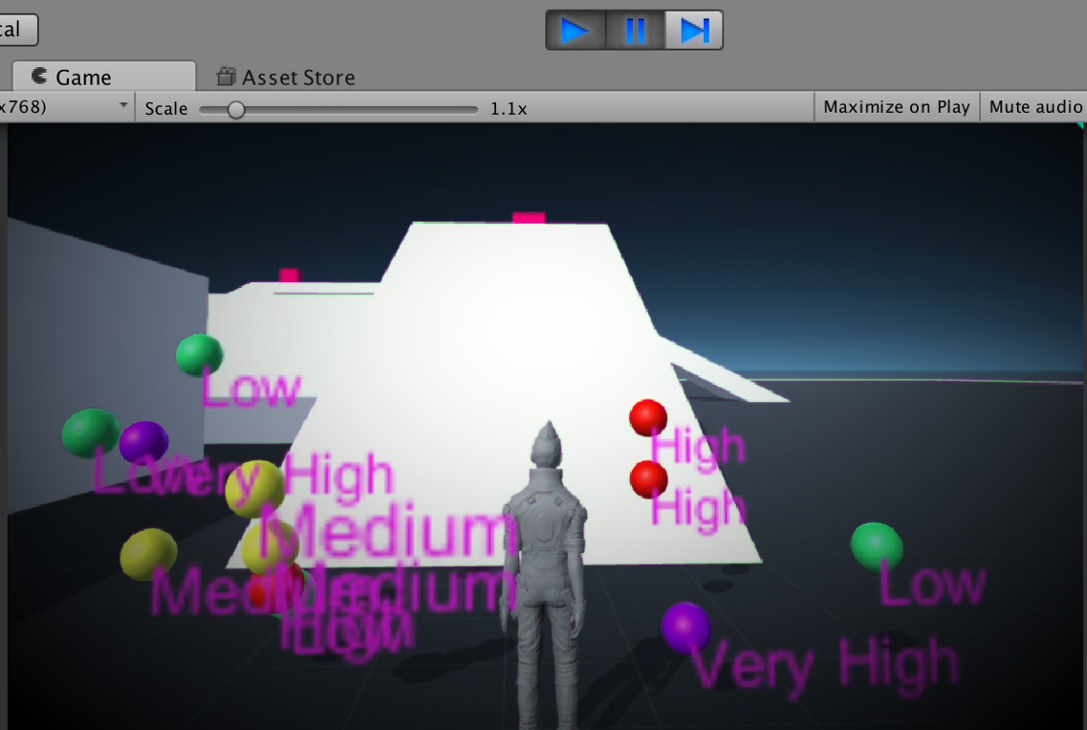Depending on whether the ecological value of the reading is very high, high, medium or low, the sphere’s colour changes (purple = very high, red = high, yellow = medium, green = low). This supports the the labelling affect.

1. Select Object (Using raycast)

**Raycasting** was used to select an object. The following screenshot shows the code for it.

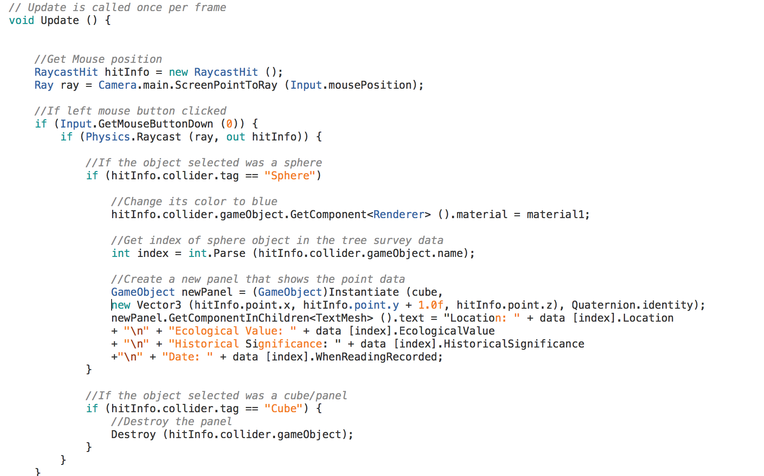

1. When Object is selected – change visible attribute

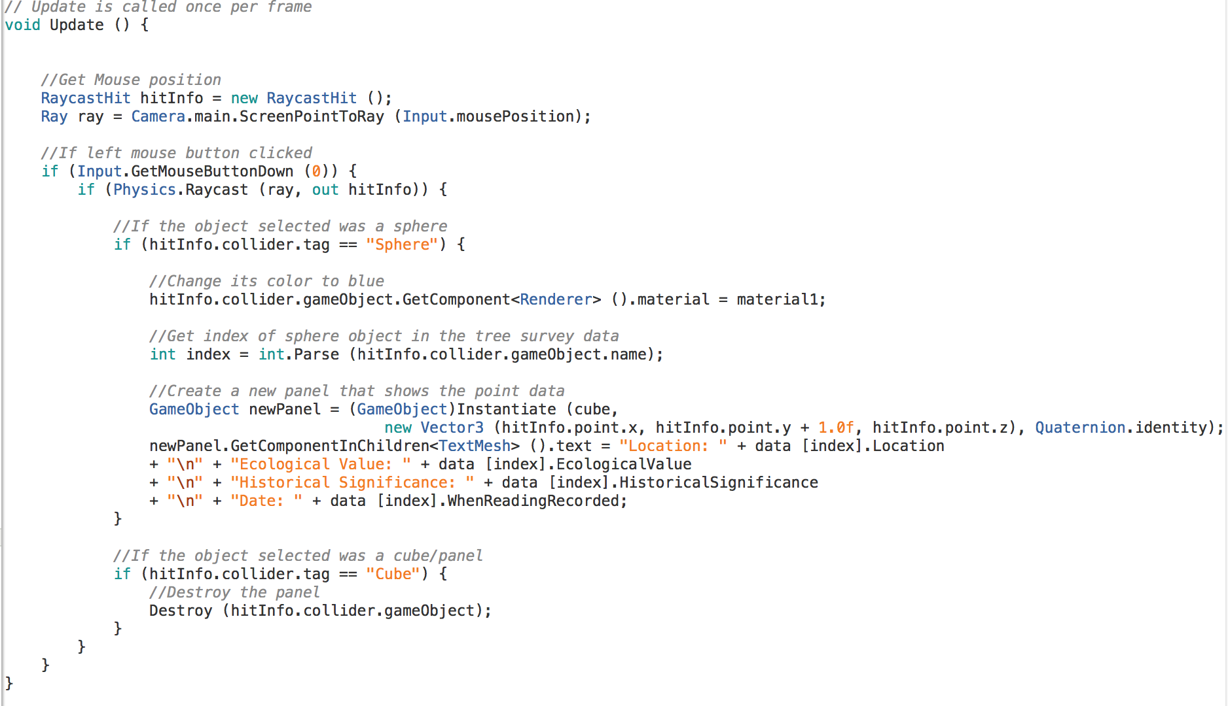So when a sphere (single reading point) is selected/clicked on then the selected sphere turns **blue**. The following screenshot shows the code for it.

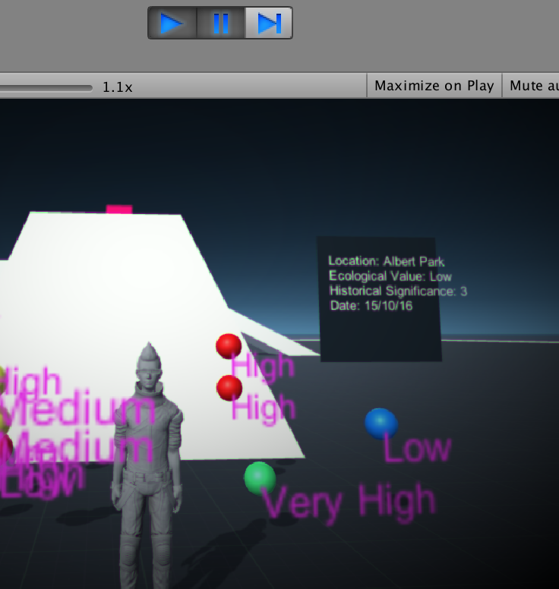

1. When Object is selected – display panel with point data

So when a sphere (single reading point) is selected/clicked on then a panel is instantiated and the text on the panel is updated to show the data related to the selected point entry. The following screenshot shows the code for it.

As seen in this screenshot, the panel is instantiated 1.0f above (y) the sphere that was selected.

The panel shows the following point data: Location, Ecological Value, Historical Significance and Date Recorded.

Another example of the panel:

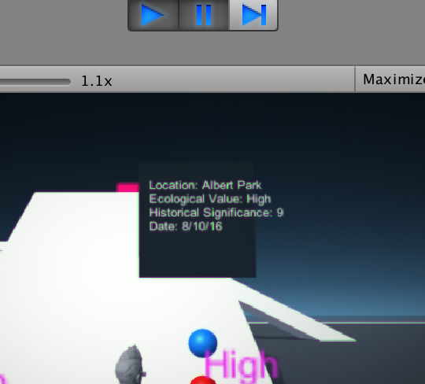

The panel can also be closed (destroyed) by clicking on the panel itself. The following screenshot shows the code for it.



1. Place Unity project in Github:

<https://github.com/chahatchawla/labtest2ccha504>